**Experiment: -1**

**Aim: - Install Xampp Server in Fedora.**

**Steps:**

**Step 1:** Download the latest version of Xampp.

Go to this page and download the latest version

https://sourceforge.net/projects/xampp/?source=directory

or open up terminal and run the following commands

Download the latest version according to your system.

wget <https://sourceforge.net/projects/xampp/files/latest/download>

**Step 2:**After the download finishes. Change the downloaded files permission to an executable. And run the file.

sudo chmod +x xampp-linux-x64-1.8.3-2-installer.run

sudo ./xampp-linux-x64-1.8.3-2-installer.run

[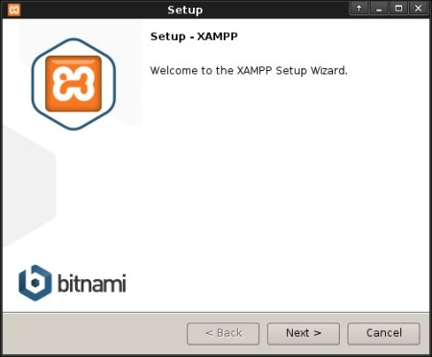](https://i0.wp.com/www.abouthack.com/wp-content/uploads/2015/04/Xampp-Setup.jpg)

If everything completes without any issue then Xampp Control Panel will run.

[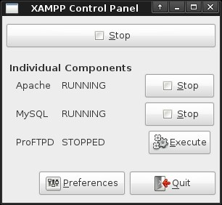](https://i0.wp.com/www.abouthack.com/wp-content/uploads/2015/04/XAMPP-Control-Panel.jpg)

**Some basic xampp commands**

cd /opt/lampp

sudo sh lampp start # start xampp

sudo sh lampp restart # restart xampp

sudo sh lampp stop # stop xampp

# without using cd

sudo /opt/lampp/lampp start # start xampp

sudo /opt/lampp lampp restart # restart xampp

sudo /opt/lampp stop # stop Xampp

